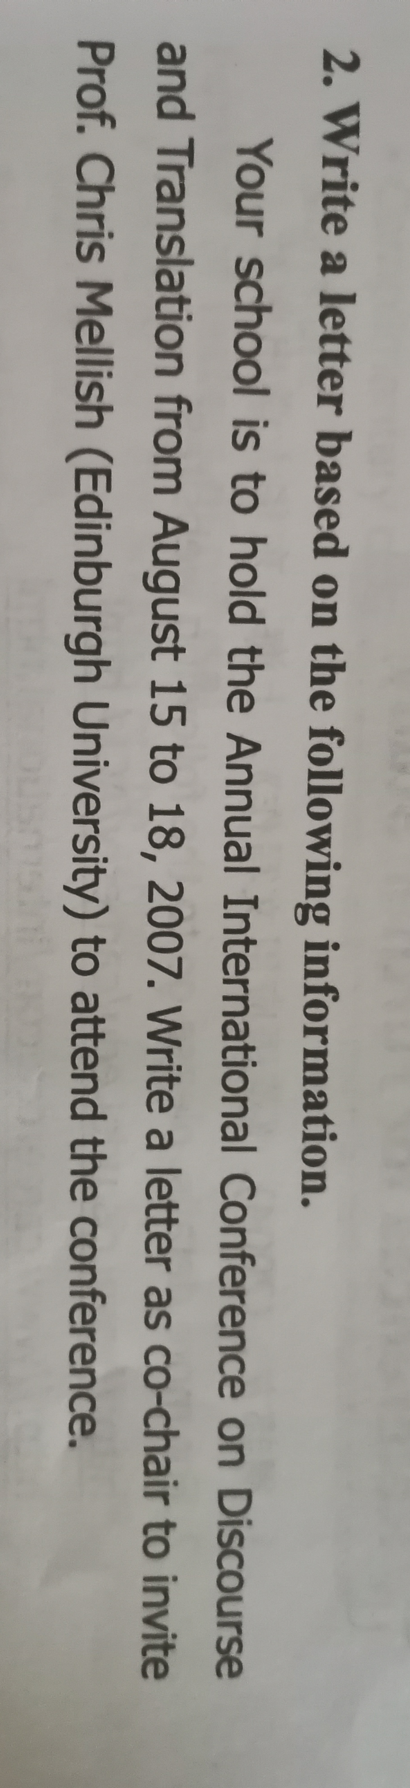

 Dear Prof.Chris Mellish,

I am the co-chair. In order to better carry out international academic exchanges and build a good communication environment, our school will hold the annual International Discourse and Translation Conference from August 15 to 18, 2007. This letter sincerely invites you to participate in this conference. Hope you Can participate in this meeting.

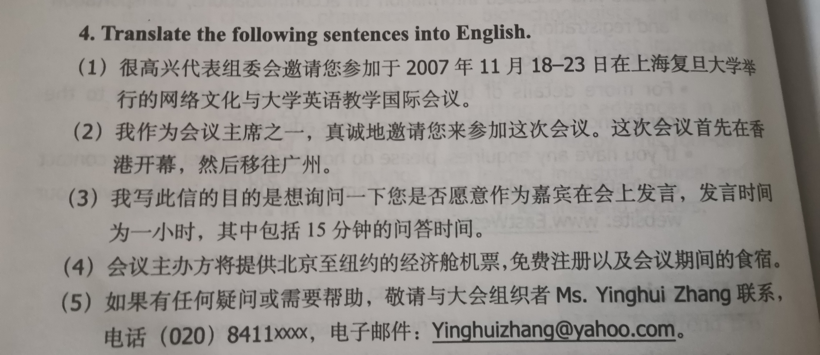

* + 1. .On behalf of the organizing committee, I am very pleased to invite you to participate in the International Conference on Internet Culture and College English Teaching held at Fudan University in Shanghai from November 18-23, 2007.
    2. As one of the chairpersons of the conference, I sincerely invite you to participate in this conference. The conference first opened in Hong Kong and then moved to Guangzhou。
    3. My purpose of writing this letter is to ask if you are willing to speak at the meeting as a guest. The speaking time is one hour, including 15 minutes for question and answer.
    4. The conference organizer will provide economy class air tickets from Beijing to New York, free registration, and board and lodging during the conference.
    5. If you have any questions or need help, please contact the organizer Ms. Yinghui Zhang at (020) 84110x, email: Yinghuizhang@yahoo.com.。

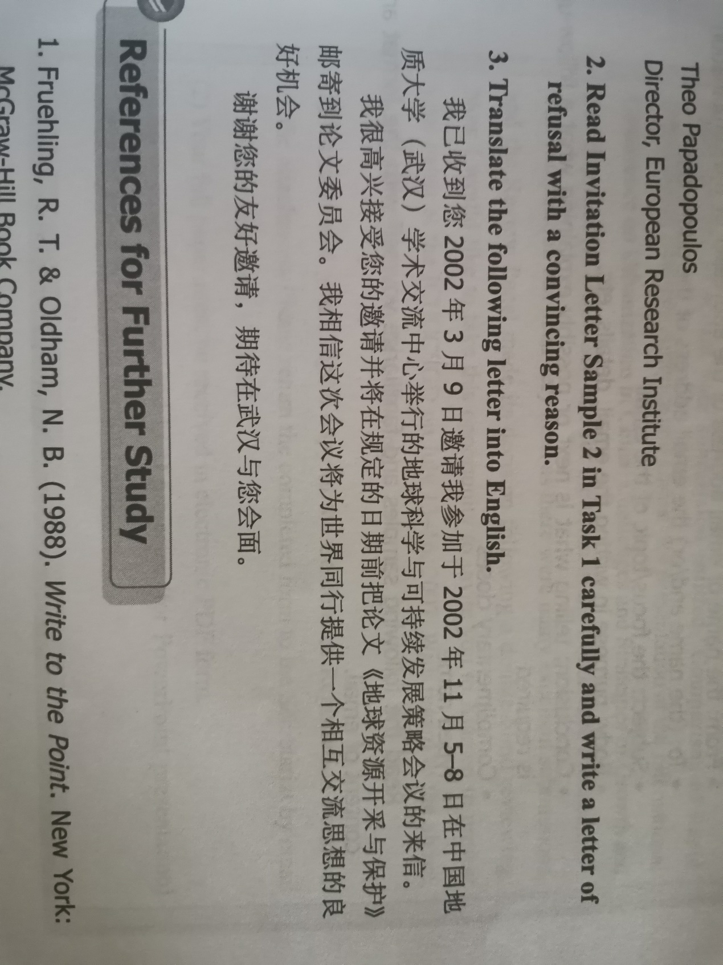

I have received your letter on March 9, 2002, inviting me to participate in the Earth Science and Sustainable Development Strategy Conference held at the Academic Exchange Center of China University of Geosciences (Wuhan) on November 5-8, 2002. I am very pleased to accept your invitation and mail the thesis "Mining and Protection of Earth Resources" to the thesis committee before the stipulated date. I believe this conference will provide a good opportunity for colleagues in the world to exchange ideas with each other. Thank you for your kind invitation and look forward to meeting you in Wuhan.

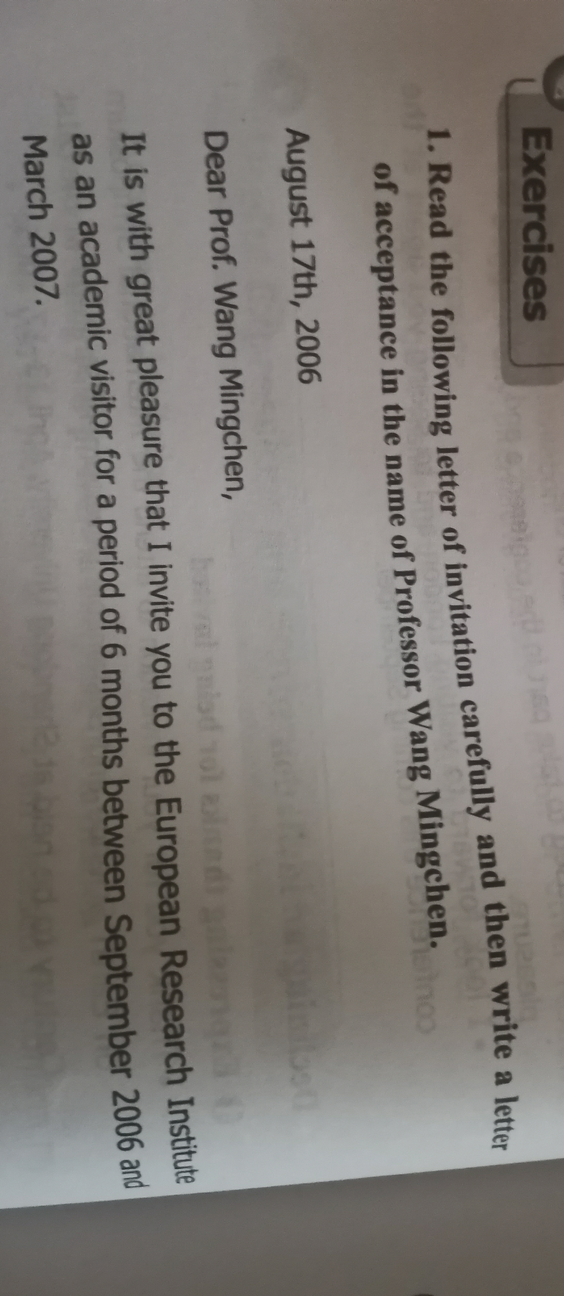

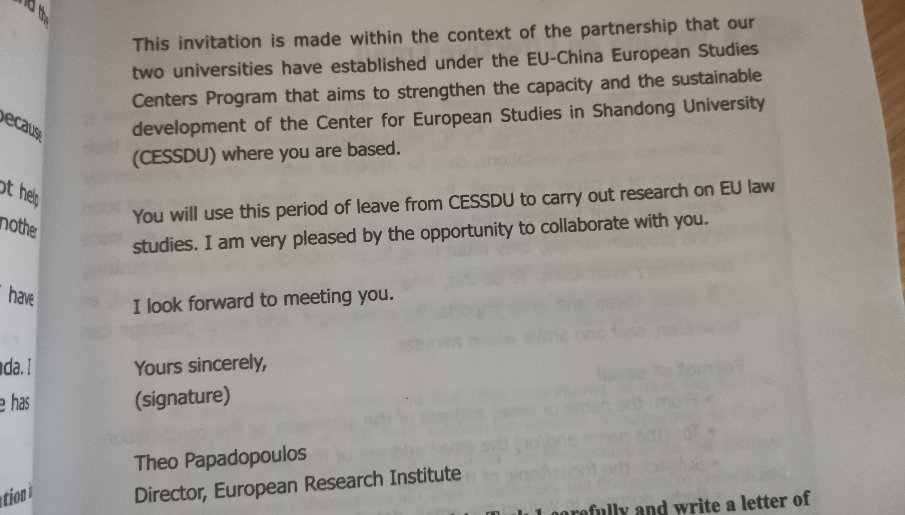

First of all, I am very happy to have this invitation with you. I am also very happy to conduct this travel research in a partnership relationship. I hope that this research can promote the friendly progress of Sino-European cooperation and contribute to the sustainable development strategy. I hope I can have a good research experience with you this time